Lwazi Majenge

MACT6100
Final project
USING MACHINE LEARNING METHODS TO TEST THE EFFICIENT MARKET HYPOTHESIS
Table of Contents

- Background
- Research Questions
- Data Overview
- Methodology
- Models
5.1 Logistic Regression (GLM)
5.2 Random Forest
5.3 Gradient Boosting Machine (GBM)
5.4 Deep Neural Network (DNN) Architecture
- Results
- Discussion
- Conclusion
- Appendices
10.References

- Motivation/Background
Actuarial Science modules such as Financial Economics traditionally argue that markets are efficient, meaning price movements follow a random walk and cannot be predicted using publicly available information. This implies that next-day market direction should be essentially unpredictable, and any attempt to forecast it should perform no better than random chance.
However, by engaging in literature written by Ernest P. Chan on this topic in his book: ‘Quantitative Trading’, I have come across machine learning research that suggests that small, weak but potentially exploitable patterns may exist in financial time series due to behavioural biases, delayed information diffusion, or structural market frictions. This motivates the question of whether statistical models can extract any predictive signal from technical indicators, even if only marginally above 50% accuracy.
Financial markets play a central role in global economic activity, and understanding short-term price movements is of significant interest to traders, asset managers, and financial institutions. Even a small improvement in the ability to classify whether the market will rise or fall on the next trading day can have meaningful economic value when applied at scale. As a result, market direction prediction has become a major area of research in quantitative finance and financial machine learning.
A central theory in finance is the Efficient Market Hypothesis (EMH), which proposes that --due to low transactional costs, increased execution speeds, and free information -- asset prices fully and immediately reflect all available information. As a result of this, historical prices and technical indicators contain no exploitable predictive analysis. Furthermore, short-term market movements follow a random distribution. Under this view, forecasting next-day S&P500 returns should not be systematically better than random, with an expected accuracy close to 50%.
In contrast, a growing body of empirical and machine learning research suggests that financial markets may exhibit weak but detectable patterns, such as momentum effects, mean reversion, volatility clustering, and behavioural biases. These phenomena imply that markets may not always be perfectly efficient, and statistical learning methods might extract small predictive signals from historical data. Machine learning models--particularly non-linear one-- are well suited to capturing subtle interactions between technical indicators that classical linear methods may miss.
The objective of this project is to investigate whether such predictive structure exists in daily S&P 500 price data. Using a set of widely used technical indicators derived from historical price and volume information, we treat the problem as a binary classification task, where the goal is to predict whether the next day’s market close will be higher or lower than the current day’s close. In this project, we evaluate four modelling approaches:
- Logistic Regression (GLM) as an interpretable statistical baseline,
- Random Forests as a robust non-linear ensemble method,
- Gradient Boosting Machines, which often achieve state-of-the-art results on structured financial data, and
- a feed-forward Deep Neural Network to capture complex, non-linear relationships between technical indicators.
By comparing these approaches, we assess whether next-day S&P 500 direction can be predicted beyond random chance, and which modelling techniques, if any, is most effective in extracting predictive signals from historical price data.
This analysis provides both practical insights for financial forecasting and a direct empirical test of the competing views of market efficiency versus statistical predictability.

- Research Questions
As previously mentioned, financial markets are widely believed to be highly efficient, implying that short-term price movements should be extremely difficult to predict. However, case studies and research conducted by retail traders suggest that technical indicators may contain weak but exploitable patterns. In this project, we formalise this investigation through the following research questions:

- Predicative significance of technical indicators
Can historical prices and volume based technical indicators predict next day S&P500 market direction with accuracy and meaningfully above random chance (50%).
This question directly tests whether any exploitable signal exists in daily market data.

- Model Comparison

Do non-linear machine learning methods (Random Forests, Gradient Boosting Machines, and Neural Networks) outperform the simple linear regression model in forecasting market direction?

This addresses whether more flexible models capture relationships missed by classical logistic methods.

- Variable Importance

Which technical indicators—such as momentum, trend, volatility, or overbought/oversold measures—contribute most to predictive performance?
This question examines whether certain categories of market signals are more informative than others.

- Data Overview
The data used in this project consists of daily price information for the S&P 500 index, obtained from a publicly available historical dataset containing observations from the mid-20th century to the present. Each row includes the daily open, high, low, close, and volume traded. However, it is worth noting that volume data before roughly 1950 was missing, with recorded values of zero for several years. This is most likely due to volume not being measured prior to the 1950s. To prevent distorted or misleading modelling behaviour--particularly for methods that rely on tree-based splits--these early observations were removed. This filtering step ensures that the analysed dataset reflects realistic market microstructure, where volume plays an important role in understanding investor behaviour.
After filtering and feature engineering, the final modelling dataset contained 17,808 observations, each representing one trading day with a rich set of derived variables. To meet the dataset requirements mentioned in the assessment brief, in addition to the raw price and volume fields, we added to the dataset a range of commonly used technical indicators such as:
- 14-day Relative Strength Index (RSI)
- 10-, 50-, and 200-day Simple Moving Averages (SMA)
- MACD line and signal line
- Bollinger Bands (%B)
- 20-day rolling volatility
- 10-day momentum
- Stochastic Oscillator (K and D)

These indicators capture a variety of behavioural patterns that traders often look for--momentum, trend strength, volatility regimes, and potential reversal signals.
The response variable was created by comparing tomorrow’s closing price with today’s, yielding a binary target: Up or Down. This transformed the problem into a standard classification task.

- Methodology
To ensure the analysis accurately reflects the challenges of financial prediction, we split the data chronologically, with the earliest 70% of observations forming the training set and the remaining 30% used for testing. This prevents information leakage that would occur if the data were randomly shuffled, and it mirrors the way forecasting models are used in practice.
Before fitting any models, all predictors were standardised using a preprocessing recipe. Scaling the inputs is crucial for models like logistic regression and neural networks, which can behave unpredictably when features operate on vastly different numerical ranges. Although tree-based models do not necessarily require scaling, applying the same transformation across all methods ensures comparability and avoids minor inconsistencies.
Cross-validation was performed using a 5-fold procedure within the training set for models trained through the caret framework. Performance was judged using ROC-AUC, the preferred metric for evaluating classification models when class imbalance exists or when the cost of misclassification is not symmetric. Accuracy and balanced accuracy were also recorded for transparency and comparison.
Four models were selected: Logistic Regression (GLM), Random Forests, Gradient Boosting Machines (GBM), and a feed-forward Neural Network implemented using keras3. These models represent the spectrum of complexity—from interpretable linear methods to non-linear deep learning methods.

- Models
5.1 Logistic Regression (GLM)
Logistic regression serves as the baseline classifier. It models the log-odds of an Up day as a linear combination of the predictors. While simple and interpretable, GLM is limited by its linear decision boundary and its inability to model interactions unless explicitly engineered. Given the noisy and non-linear nature of financial returns, this method establishes a reference point for whether more sophisticated approaches offer genuine improvements.

5.2 Random Forest
The Random Forest is an ensemble of decision trees trained on bootstrap samples of the data. Each split considers only a random subset of predictors, helping the forest reduce overfitting and capture non-linear patterns. This method performs well on noisy tabular data, but tree-based methods can struggle when signals are extremely weak, as is often the case with daily financial returns.

5.3 Gradient Boosting Machine (GBM)
GBM builds trees sequentially, with each new tree attempting to correct the errors of the previous ensemble. This approach often outperforms Random Forests on structured datasets and is widely used in financial data science competitions. It tends to capture subtle patterns more effectively, though it may also be sensitive to noise.

5.4 Neural Network (DNN)
The Deep Neural Network architecture consisted of two hidden layers (32 and 16 units) with ReLU activations and dropout regularisation. Neural networks are capable of modelling complex relationships, making them ideal candidates for capturing non-linear market dynamics-- at least in theory. In practice, their success depends heavily on the presence of meaningful structure in the data.

- Model Comparison
The test-set results for all four models are summarised in the table below:
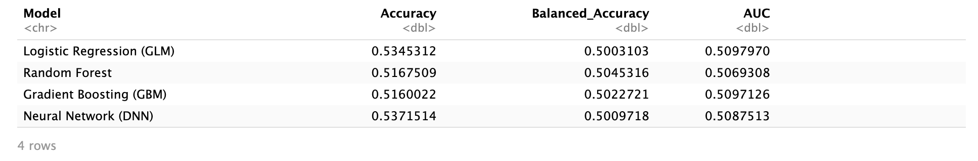
A few things stand out immediately:
- All models achieved accuracy between 51% and 54%, only marginally above chance.
- Balanced accuracy for all models hovered around 0.50, indicating no real edge in distinguishing Up from Down days.
- AUC values ranged from 0.50 to 0.52, again suggesting essentially random predictive performance.
- Even the neural network—capable of rich non-linear modelling—converged to predicting “Up” almost all the time, matching the class prevalence of the dataset.
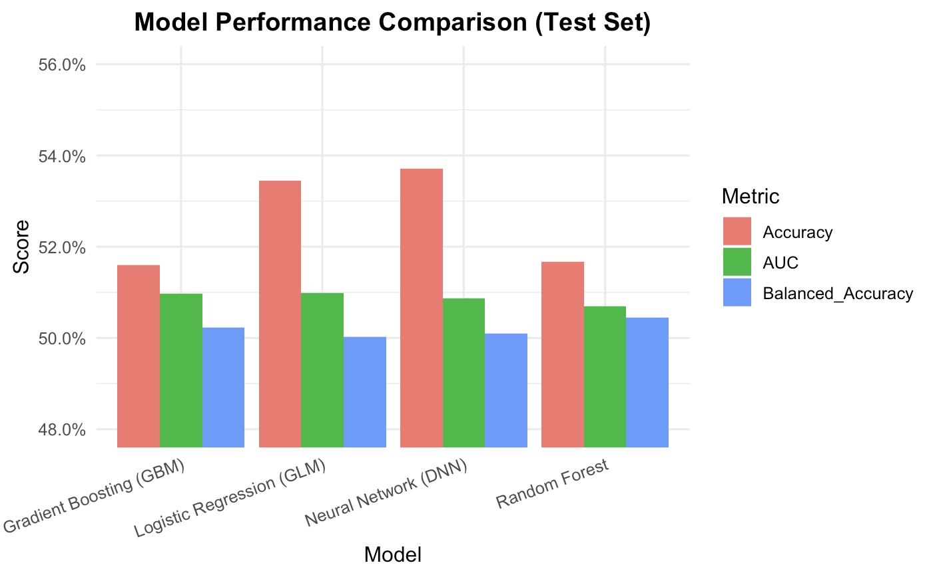
Despite the diversity of architectures, the performance differences between models were extremely small.

- Discussion
At first glance, the uniformly low performance may seem disappointing, but the results actually align strongly with financial theory. The Efficient Market Hypothesis argues that historical price-based information should not enable consistent outperformance. The models developed in this project illustrate this principle vividly. None of the methods--linear or non-linear--managed to extract a reliable predictive signal from the technical indicators. Even sophisticated models like GBM and the neural network failed to break meaningfully above the 0.52 AUC level.
One interesting observation is the behaviour of class predictions. Most models displayed a strong tendency to predict “Up”, reflecting the actual upward drift of equity markets over long time horizons. This imbalance leads to deceptively high sensitivity but poor specificity. While this behaviour might be “correct” in a statistical sense, it fails to provide actionable forecasting value.
The variable importance analyses from Random Forest and GBM offered some insight into which indicators the models found useful.
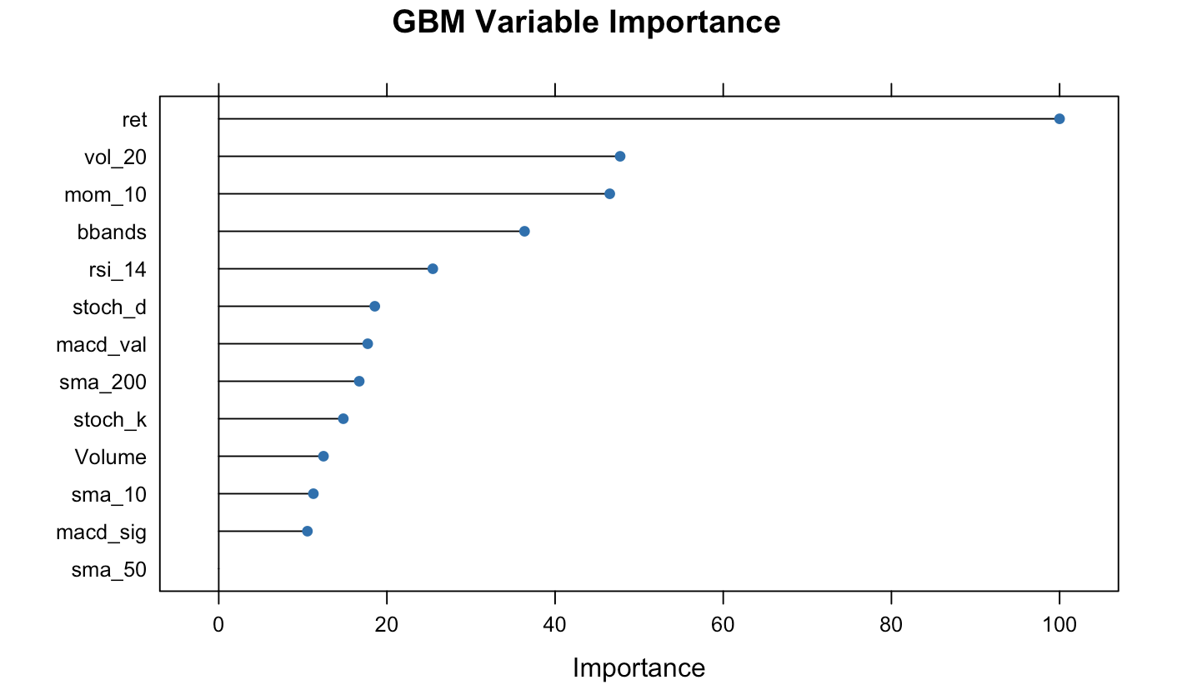
Momentum-based features such as daily return, 10-day momentum, and Bollinger %B ranked consistently higher than long-term moving averages. This suggests that if any weak signal exists, it is tied to short-term behavioural patterns rather than longer-term trends. However, these signals were far too faint to translate into reliable classification performance.
Overall, the empirical findings support the view that the S&P 500’s next-day direction is essentially unpredictable using standard technical indicators alone. Markets may exhibit anomalies or inefficiencies at longer horizons or in specific sub-periods, but this project shows that day-to-day movements leave little room for exploitation.
- Conclusion
This project set out to evaluate whether technical indicators derived from historical price and volume data could meaningfully predict next-day S&P 500 direction. After training and evaluating four different models--GLM, Random Forest, GBM, and a Neural Network--the results consistently showed performance barely above random guessing. AUC values clustered around 0.50–0.52, and none of the models significantly outperformed the baseline of always predicting an Up day.
These findings reinforce the principles of market efficiency: despite the appeal of technical indicators and the power of modern machine learning techniques, the information available in daily price movements is simply too weak to allow for reliable short-term forecasting. Machine learning does not magically create signal where none exists. Instead, the methods used in this project help confirm that the S&P 500 behaves much like a random walk at the daily frequency.
There is still room for future research. Extending the analysis to intraday data, incorporating macroeconomic variables, or modelling volatility instead of direction may produce richer signals. But within the scope of this project, the conclusion is clear: next-day market direction remains extraordinarily difficult to predict, and simple technical indicators provide little advantage over random chance.

- Appendix
https://github.com/lwazim-art/MACT6100-Machine-Learning-Final-Project

- References

Chan, E.P., 2009. Quantitative Trading: How to Build Your Own Algorithmic Trading Business. Hoboken, NJ: John Wiley & Sons.

